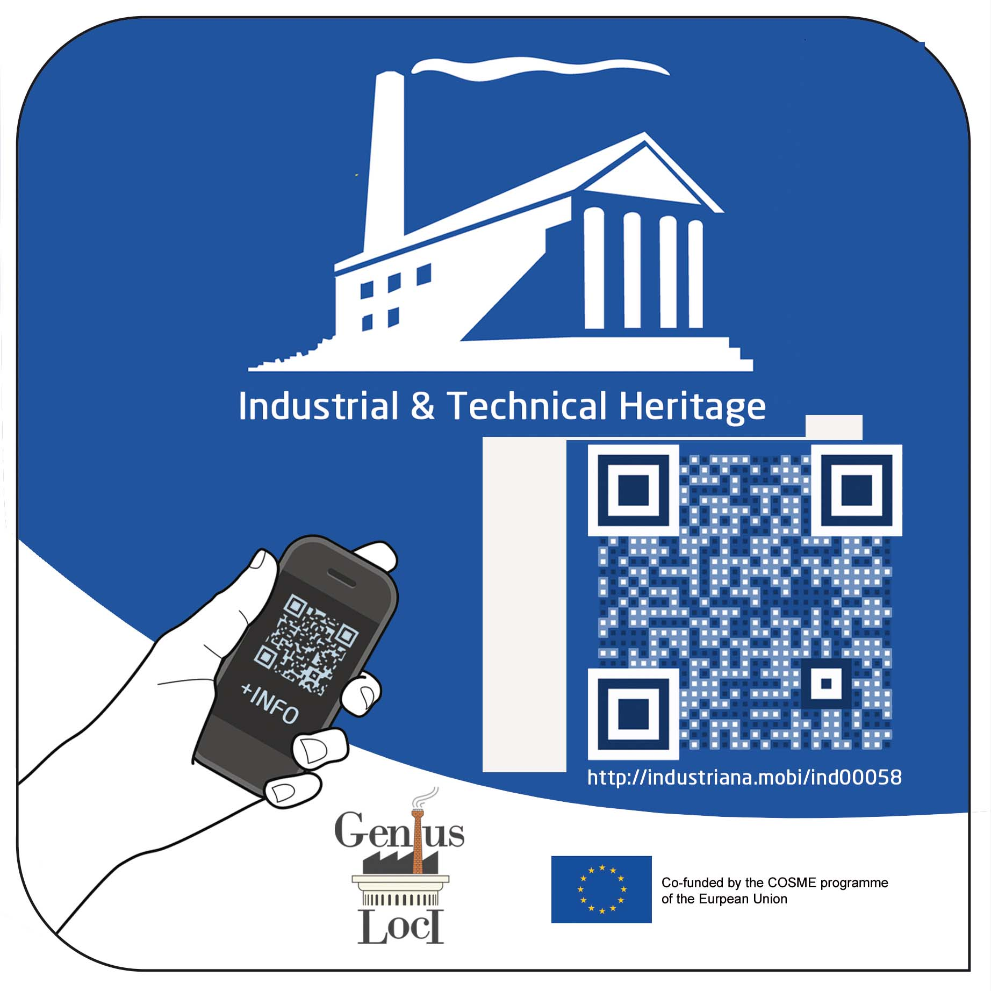
The INDUSTRIANA QR European industrial heritage label

EFAITH, the European Federation of Associations of Industrial and Technical Heritage has developed a unique industrial heritage label with QR-code – which can be posted at the door or wall of your site, museum, or industrial heritage initiative.
(see http://industriana.eu/).
Thus the site will be included in the Industriana app and the maps connected with this project. It will enable the passer-by to access information about the site and its history when using their smartphone.or via the Industriana website.

If you would like to obtain an Industriana label for your site, museum or heritage initiative, please complete the questionnaire and return it as soon as possible. Add some documentation and pictures.
If you know of any site or organisation that qualifies for inclusion in the network, please forward this questionnaire and encourage them to fill it in and return it to the secretariat
The conditions to join are the following
1.- By submitting this questionnaire, you formulate your candidacy to obtain a label
2.- Your application will be judged among other things on heritage and historical values, the way the site or collection are presented, etc..
3.- When your candidacy has been accepted, you will receive a confirmation, a second questionnaire (asking for the texts, pictures,etc.. to be added to the Industriana QR-database) and an invoice
4. The cost charged for the Industriana label is € 175.- This is a one-off cost– there are no further subscription or set-up costs. It includes the 'standard' all weather shield 15x15cm, packed & shipped to your door in Europe. It also includes the unique QR code of your site on Industriana.eu, the inclusion on the Industriana-website.
If acquiring more than 5 labels, ask for a discount.
5. Members of EFAITH receive a discount of € 25,-

Completed candidatures and additional details, using the questionnaire, should be returned to:
secretariat@e-faith.org
p/a European Federation of Associations of Industrial and Technical Heritage
Vredelaan 72 B-8500 Kortrijk (Belgium)

CANDIDATURE FOR AN INDUSTRIANA QR LABEL

NAME OF THE SITE
Country + region
Zip/post code + Town/municipality
Address
(number, street)
GPS location
Telephone
E-mail address
Contact name
Website (if any)
Topic  What are the topics/themes you are dealing with ? | e.g mills, steam engine, brewery, brickworks, bridge, …
accessibility | - Historic site open to the public  - Historic site not open to the public  - Re-used building  - Museum  - Private collection  - Interpretation / visitor centre  - SME still producing in the traditional way  - Folklore linked with the industrial activities  - Other……..  (you can select more than one category)
- Add a description
- Please add some additional documentation
- Please provide some pictures

I agree that EFAITH / Industriana may contact me to receive further and detailed information if this site is accepted to receive the European Industrial Heritage Label ‘Industriana’

Name of the person who completed this form

Representing (organisation, institute, company)

How can we reach you: by phone, skype or e-mail?

Date

Signature

